Installation
The LRE Analyzer is a standalone Java program that does not require any administrator privileges for installation. Simply unzip the LRE Analyzer folder (e.g. lreanalyzer086) to a convenient location, go to the “bin” directory and start the program by selecting the lreanalyzer086.exe file, or create a shortcut (Windows: drag + Alt). The only requirement is that Java SE6 be installed.
The program has been extensively tested on Windows XP, and has been found to function under UNIX. However, note that Apple only supports Java SE6 on 64-bit capable Intel-based Macs running OS X 10.6 and 10.5. The most current updates for 10.5 and 10.6 can be found here:
http://support.apple.com/kb/DL1359
http://support.apple.com/kb/DL1573

1) Adjust the panels
When first started, the program will display three rather large panels:

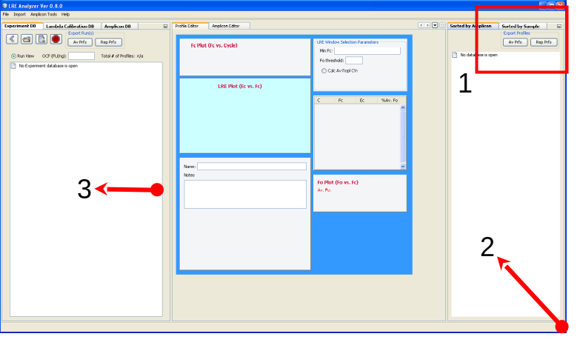
Start by first iconizing the two right hand panels by clicking on the square located at the top right. Then reduce the program window by dragging the bottom right corner, and reducing the left hand panel by dragging the divider to the left:

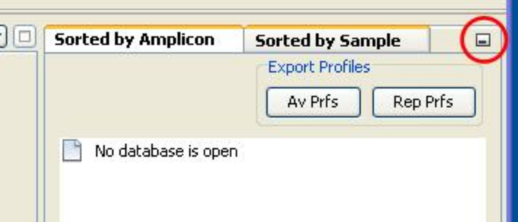
This leaves the explorer and editor panels, with the sorting panels displayed as buttons on the right hand boarder. Note that these changes are saved so that when the program is restarted, it will retain the same configuration.

: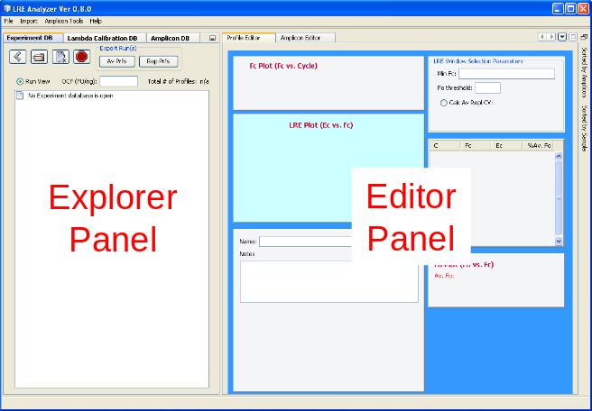

2) Load the demonstration experiment database
Demonstration databases were provided as part of the zip file containing the LRE Analyzer program. Note the four buttons in the top left hand corner of the explorer panel, which allows experiment databases to be opened, closed and created:
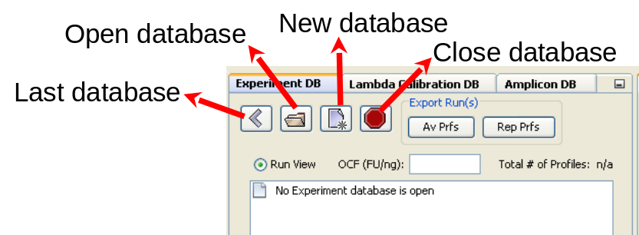

Click on the open database, navigate to directory where the demonstration databases were unzipped, and select “LRE Experiment Database Ver 0.8.exp”. The explorer panel should then display a tree listing the three runs contained within this database:
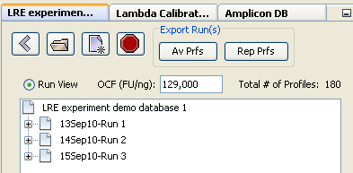

Clicking on the plus icon beside a run will open it to display all of the amplification profiles within the run, which in this case is the quantification of three reference gene targets within three replicate cDNA samples (COL1-3). Each label consists of “amplicon name” @ “sample name” (amplification efficiency) N= number of transcript molecules:

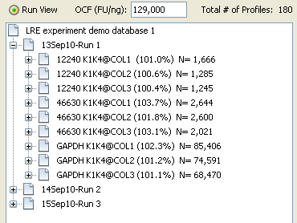

Clicking on a profile will display all of the information associated with that profile within the editor window:

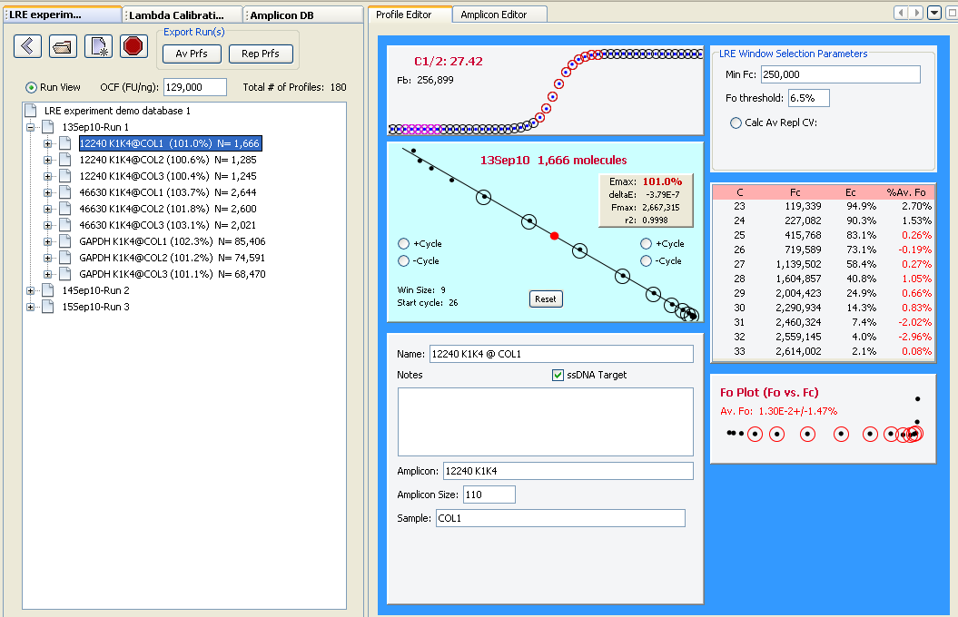
Although a large amount of information that is displayed, the most important is the LRE Plot, which is the kinetic analysis from which amplification efficiency (E_{max}) and target quantity (1,666 transcript molecules) are derived (see below for more details as to how target quantity is determined) :

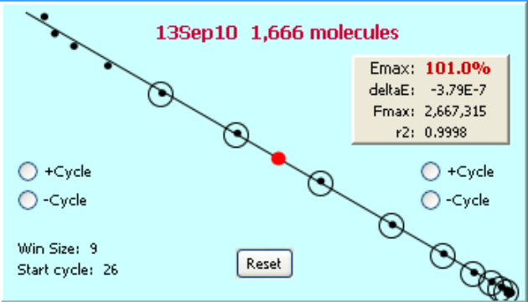

3) Sorting data for viewing and export
Although data can be exported in a run-based format, the sorting panels located on the far right boarder can be used to sort data either by amplicon or sample. Hovering the mouse over their icons will cause a panel to fly out, which in this example displays a list of all the amplicons present within the demonstration database:

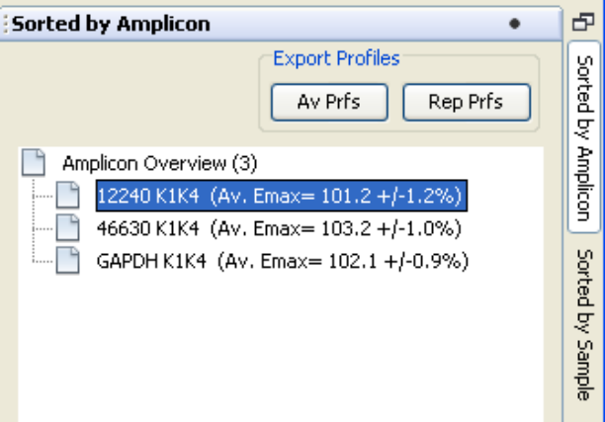

Selecting an amplicon will trigger the Explorer Panel to list all of the profiles produced by this amplicon:
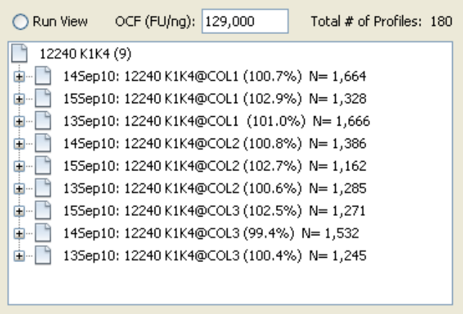
In this case, these are the nine profiles produced by the 12240 K1K4 amplicon, along with their respective amplification efficiencies and the number of transcript molecules within each of three cDNA samples (COL1-3).

Note that these quantifications were conducted over three runs, illustrating the central utility of this list, which is to examine data generated across multiple runs. Here, these consist of three replicates quantifications conducted within each run, from which run-to-run variance to be evaluated. Note also that Col1-3 are cDNA samples generated from the same RNA sample, such that the variance of reverse transcription can also be evaluated (see Figure 14 in Rutledge (2011) for a summary of this analysis).

These sorted lists also allow data to be exported either by amplicon or sample, allowing data generated across multiple runs to be exported as a group into a MS Excel worksheet. Here is an example for 12240 K1K4:

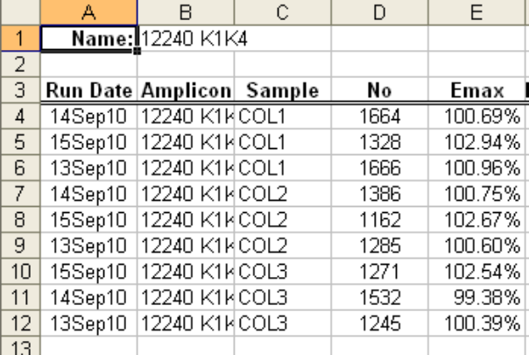

Selecting multiple amplicons (e.g. Windows: Ctrl + left click) generates a workbook containing a worksheet for each amplicon:

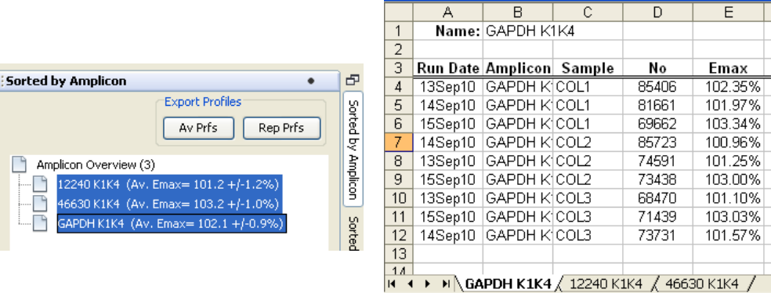

Thus the sorting panels not only allows viewing of data generated across multiple runs, it also allows data to be exported in an organized fashion.

Extensive information is provided by the help dataset within the program about how to use the program, including details of the optical calibration and amplicon databases (not discussed here), in addition to guidelines on how setup and test qPCR assays. As time allows, additional features will be described.

A brief overview of how LRE qPCR functions
Note that detailed descriptions of how LRE qPCR was developed and testing of its performance capabilities have been published (Rutledge & Stewart 2008a; Rutledge & Stewart 2008b; Rutledge & Stewart 2010). This description is only intended to provide a general understanding of how LRE-based quantification is conducted, which is based on analysis of the SYBR Green I fluorescence readings generated by real-time PCR, and thus can be applied to any generic qPCR instrument that allows raw fluorescence readings to be exported.
Based on adapting the classic Boltzmann sigmoidal equation to PCR amplification, the following equation allows the fluorescent readings within the central region of an amplification profile (F_{C}) to be converted into target quantity expressed in fluorescence units (F₀), based on cycle number (C), the height of the profile (F_{max}), and amplification efficiency (E_{max}):

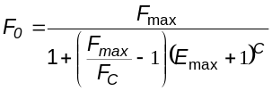

This generates 3-8 determinations from each amplification profile, which are visually displayed in the F₀ Plot:

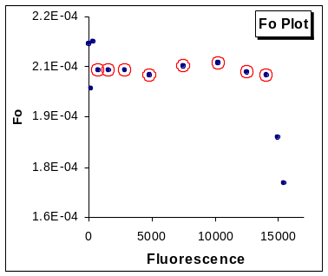
These F₀ values are averaged and converted into DNA mass (M₀) using an optical calibration factor (OCF = fluorescence units per ng), generated by amplification of a known quantity of lambda genomic DNA, an approach analogous to that used for quantification of nucleic acids using fluorescent dyes. This is followed by conversion into the number of target molecules (N₀) based on amplicon size (A_{s}):

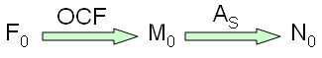

The predominate attribute of this approach is that does not require construction of target-specific standard curves. Furthermore, the performance of LRE qPCR has been extensively tested, demonstrating that quantitative variances of ±20-25% can be routinely achieved, along with maintaining accuracy down to a single target molecule. These studies have also used limiting dilution assay to confirm absolute accuracy.

References

Rutledge, R.G. & Stewart, D., 2008a. A kinetic-based sigmoidal model for the polymerase chain reaction and its application to high-capacity absolute quantitative real-time PCR. BMC biotechnology 8, 47.
Rutledge, R.G. & Stewart, D., 2008b. Critical evaluation of methods used to determine amplification efficiency refutes the exponential character of real-time PCR. BMC molecular biology 9, 96.
Rutledge, R.G. & Stewart, D., 2010. Assessing the Performance Capabilities of LRE-Based Assays for Absolute Quantitative Real-Time PCR. PLoS ONE, 5 e9731.
Rutledge, R.G., 2011. A Java Program for LRE-based Real-time qPCR that Enables Large-Scale Absolute Quantification PLoS ONE 6, e17636.

